# **Announcing Fleet Freedom Version 4.7**

Good day Fleet Freedom clients. Last month we released a bunch of new exciting report features such as emailed reports and Excel files with a horizontal layout. Other updates included Linger Notifications and the Places Closest to an Asset search.

This month’s release notes are going to be short and sweet. They focus mainly on the major improvements to the Behaviours User Interface and provisioning tool. We have also pushed out any bugfixes and overall performance improvements.

Version 4.7 will be released Thursday, August 10th 2017. Don’t forget the most important step: Clear your internet browser history and cache after an update. This is to ensure there is no old cached data or cookies that may cause issues.

## **New Features and Improvements**

Behaviours -The goal for this month’s release was to make the Behaviours section more user friendly and easier to navigate.

* Context is given for all script values. This gives the user more information on how to best configure the system.
  + For example, speed parameters such as km/hr or mph and time parameters hh:mm:ss, are more clearly defined based on your User Preferences.
* Auto-complete is now available for Users, making setting up notifications much easier. As you start typing out the Username, simply select the appropriate name from the drop down list that appears.

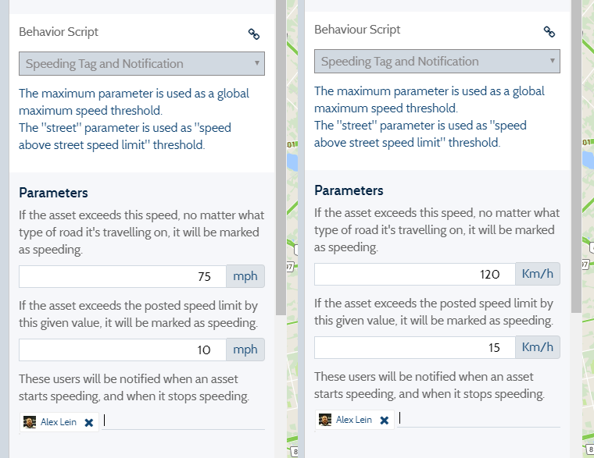

**Assign an Asset to a Device During Setup** – We are always looking for ways we can streamline the provisioning process, making it easier for you to add assets to Fleet Freedom.

* 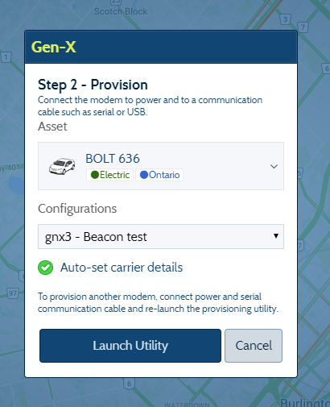You can now assign assets to a device as you add it to Fleet Freedom. This option is available for all device types. Devices can still be provisioned without an associated asset.

**Let us know what you think! Your feedback is invaluable -** As always, we appreciate your ongoing feedback of Fleet Freedom. Please continue to communicate with our Support and Sales teams to provide additional feedback of Fleet Freedom on how we can better serve your geolocation needs.

For any questions, comments or concerns, please email support@fleetfreedom.com or speak with one of our customer service reps at: 1 (866) 787-2548, Ext 2. Our call center is open from 8:30 AM to 5 PM EST, Monday to Friday.

Thank you very much for your continued business and loyalty to Fleet Freedom. It is our honor to provide you with solutions that you rely on day to day to help manage your business.

Sincerely,

The Fleet Freedom Team